Mewah Bangunan
BA23-005-Dicky = Rp. 35.115.000
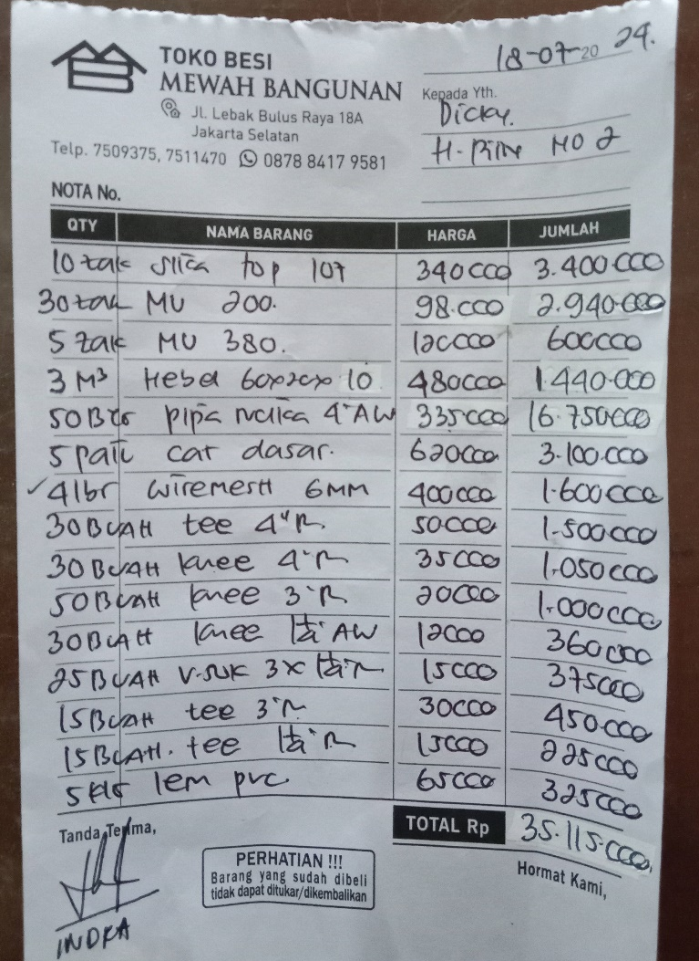

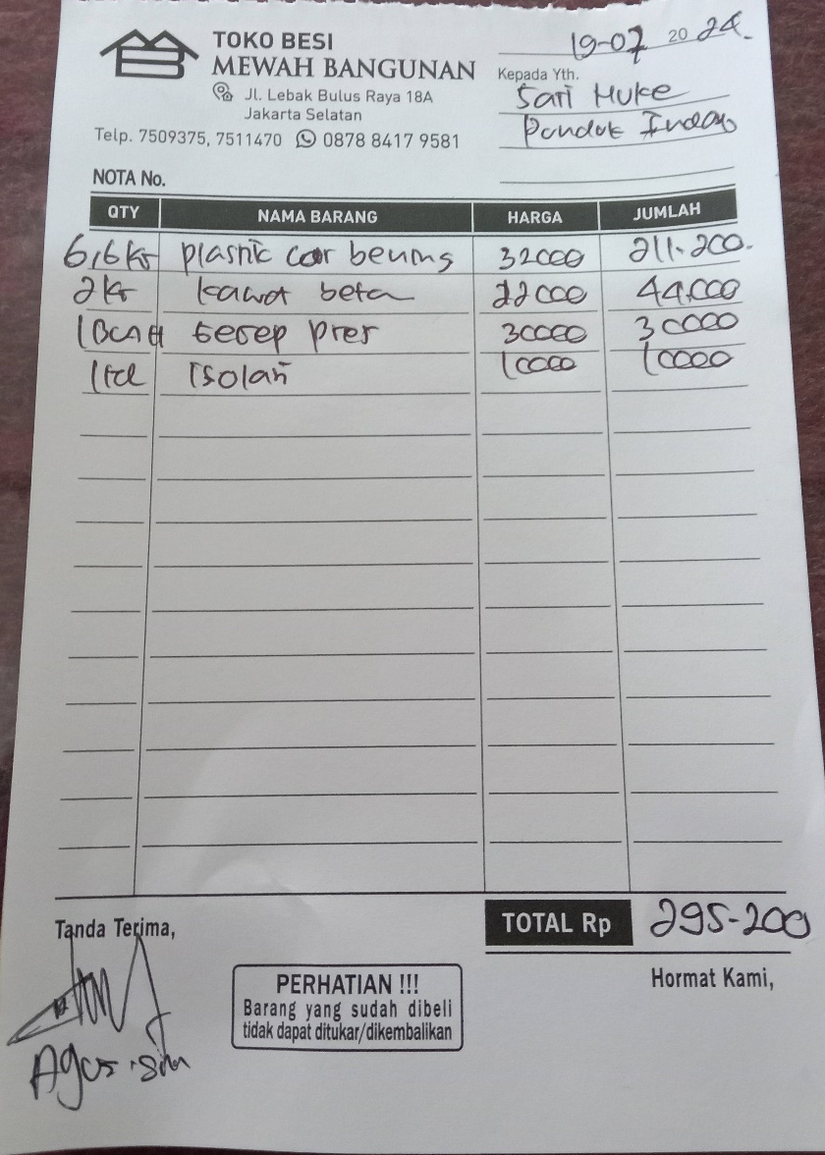
BI23-002-Sari = Rp. 295.200

