Mewah Bangunan
BA23-005-Dicky = Rp. 140.000
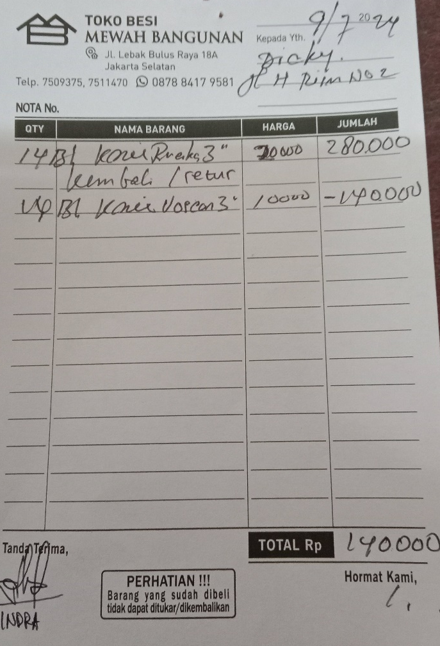

BI23-002-Sari = Rp. 22.000
