Mewah Bangunan
BI23-002-Sari = Rp. 791.000
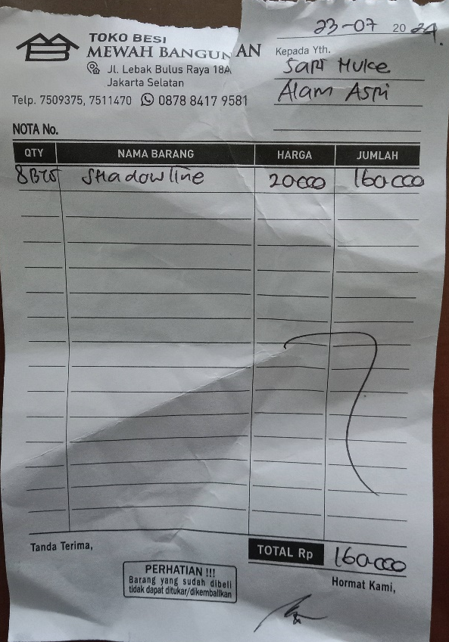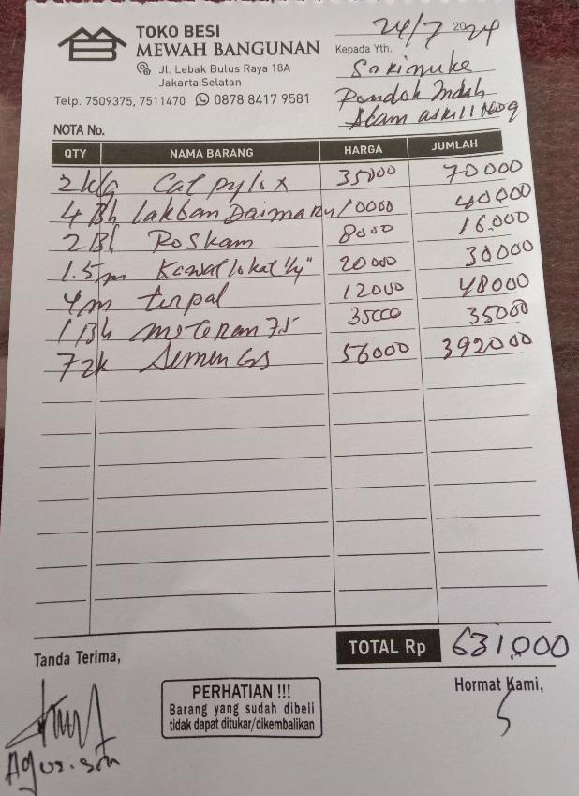

BI24-003-Yovita = Rp. 1.700.000
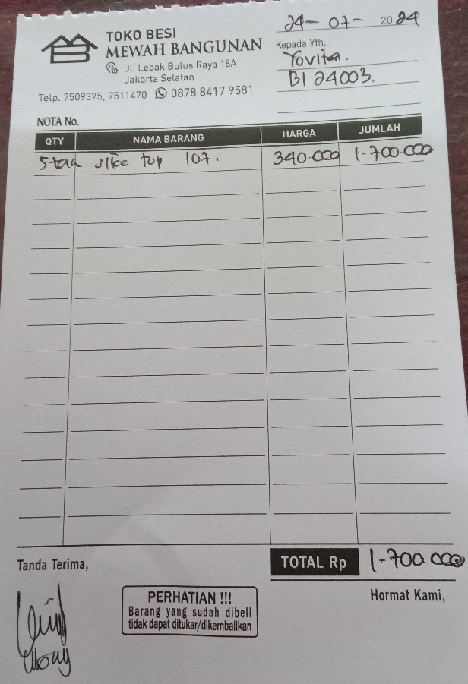

ASS24-001 = Rp. 3.253.000
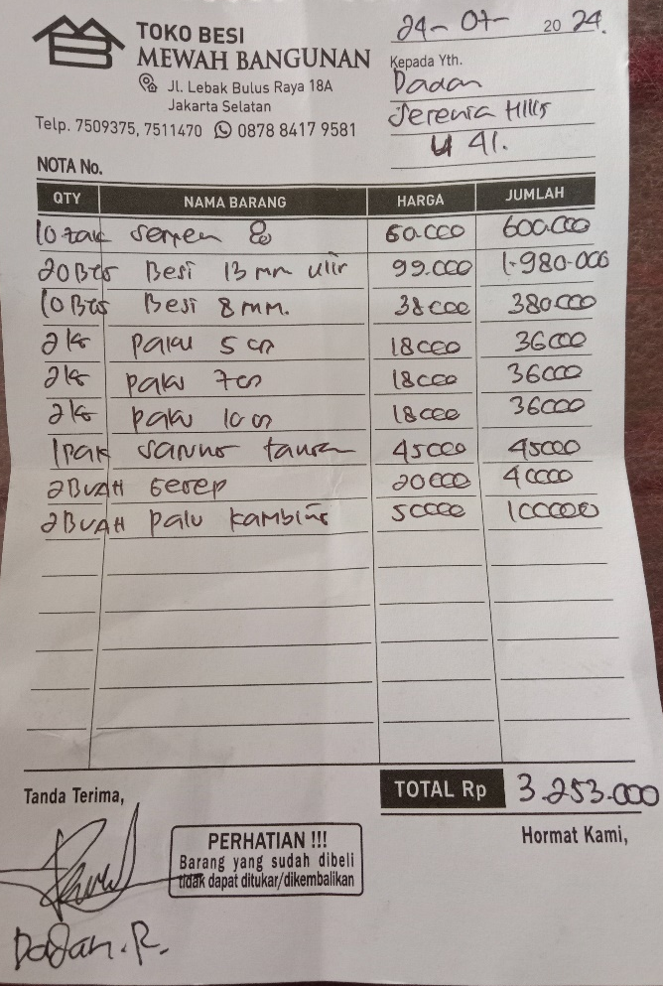

BI23-005-Dicky = Rp. 16.772.000
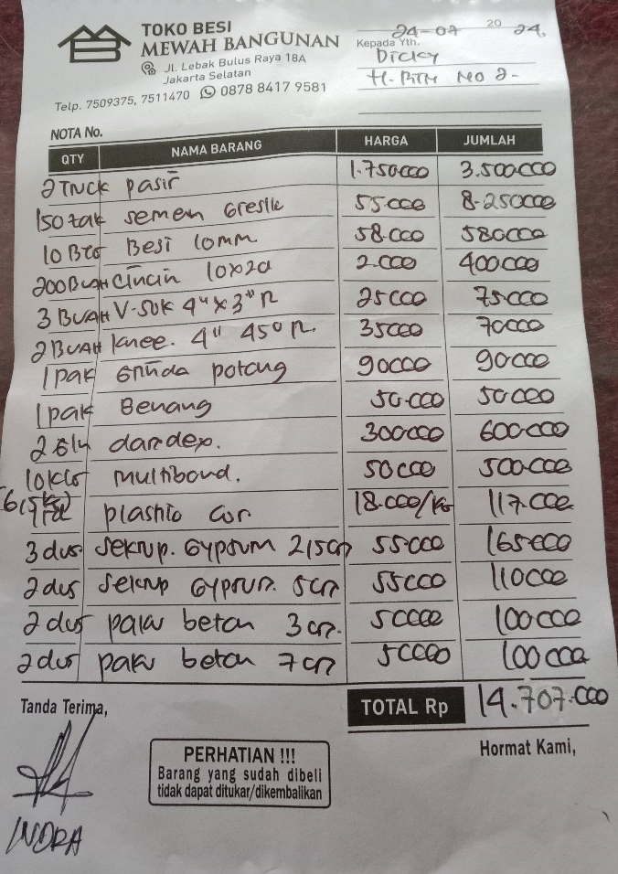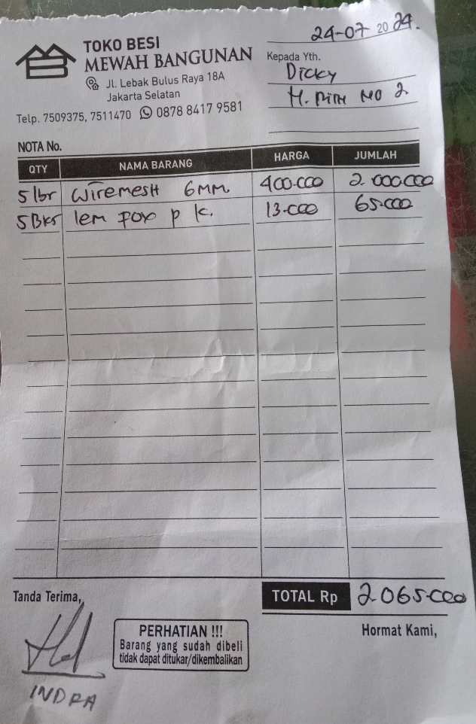

AI24-001-Wulan = Rp. 1.700.000
