Mewah Bangunan
BI23-002-Sari = Rp. 2.131.000
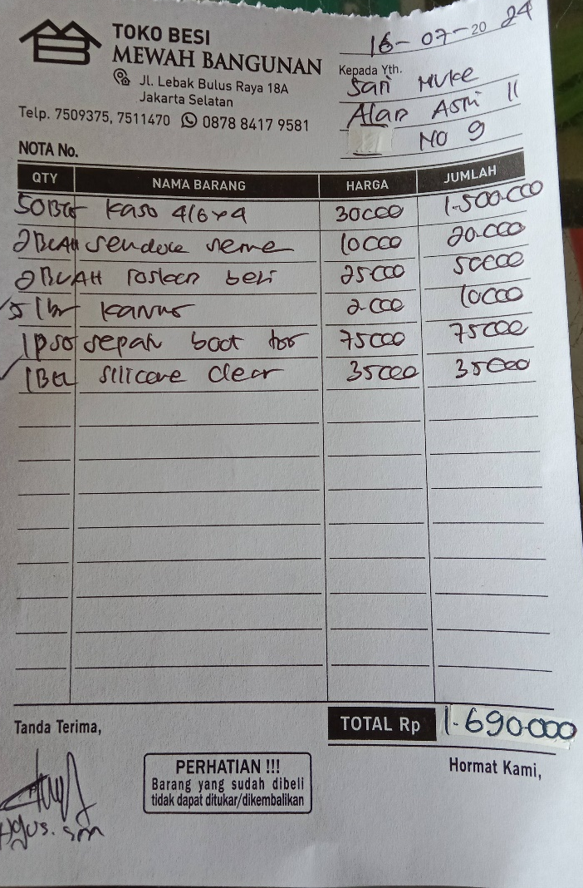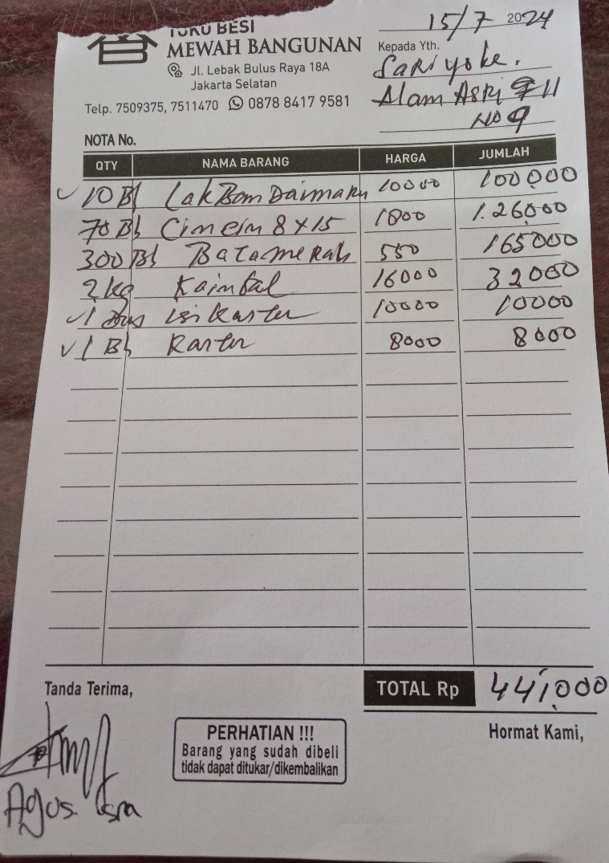

BA23-005-Dicky = Rp. 6.336.000
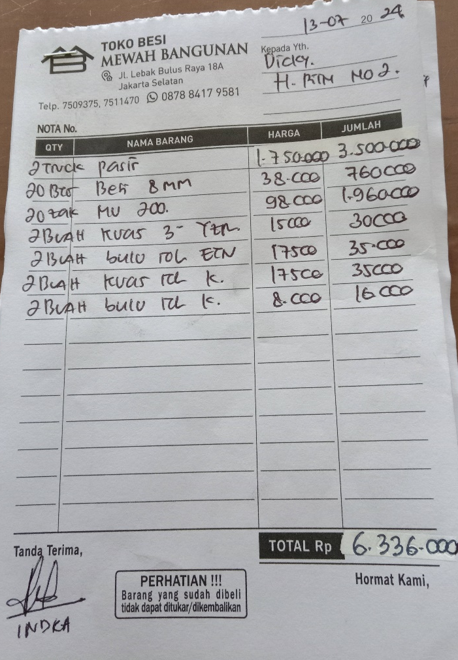

BI23-039-Oky = Rp. 366.000
